

The information in this document is confidential and meant to be used only by the intended or authorized owner, it contains confidential, proprietary or legally privileged information. No confidentiality or privilege is waived or lost by any miss-transmission. If you receive this document in error, please immediately delete it and all copies of it, destroy any hard copies of it and notify the  
TIMWE Asia Pacific Sdn Bhd. You must not, directly, use, disclose, distribute, print, or copy any part of this message if you are not the intended or authorized owner.

Presented by:

TIMwe Asia Pacific Sdn Bhd

Suite 18-02, Level 18, GTower 199 Jalan Tun Razak, 50400, Kuala Lumpur, Malaysia

Technical Solution Document

9537 New view for Canvasser in Mobile App Previous Current Month Week; Sell-IN Starter Pack Qty; Sell-IN Balance

January 7, 2019

This document outlines the technical solution for development.

# VERSION HISTORY

|  |  |  |  |
| --- | --- | --- | --- |
| Version | Date | Change | By |
| 1.0 | 01/07/2019 | Release of document | Gunarto |
| 1.01 | 02/11/2019 | Add more detail on current solution and request description | Gunarto |
| 1.02 | 02/19/2019 | Add information on Functional Requirement | Gunarto |
| 1.03 | 03/25/2019 | Added solution description | Arun SP |
| 1.04 | 04/08/2019 | Added Saldomobo API details | Arun SP |

# APPROVAL SIGN-OFF

The undersigned accept this document as described herein.

|  |  |  |
| --- | --- | --- |
| 1. **NAME** Project Manager (TIMWE) |  |  |
|  | Signature | Date |
| 1. **NAME** Position |  |  |
|  | Signature | Date |
| 1. **NAME** Position |  |  |
|  | Signature | Date |

Contents

VERSION HISTORY 1

APPROVAL SIGN-OFF 2

CURRENT SOLUTION 4

REQUEST DESCRIPTION 5

SOLUTION DESCRIPTION 7

Technical Solution 7

Specifics of the technical environment 7

Data requirements 7

External interfaces 8

Development effort and milestones 8

# CURRENT SOLUTION

Current solution of outlet views at Mobii App, reporting information transaction for sell in starterpack & SaldoMobo balance, and physical ending stock starter & saldo for every outlet. This information can be view by team sales (SAM, CSM and Canvasser) on application (Mobile App).

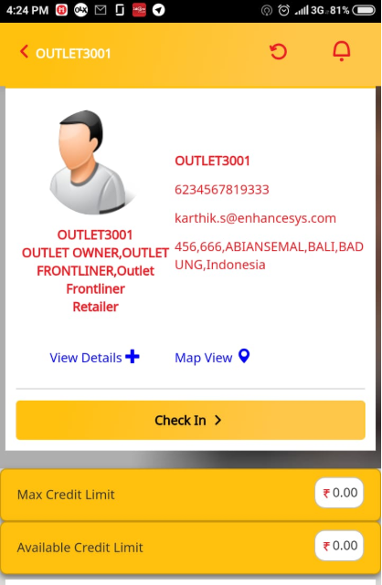

+view detail:

* 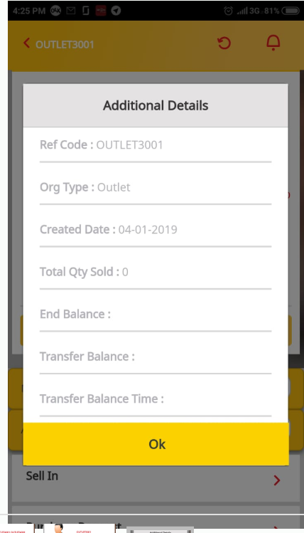Ref code
* Org Type
* Created Date
* Total Qty Sold
* End Balance
* Transfer Balance
* Transfer Balance Time
* Last Visited Time
* Last Visited User

# REQUEST DESCRIPTION

1. New menu on Mobii Application that shown on real time stock (Physical stock of starterpack and voucher) with parameter number of Sell in, Sell out, activation.
2. Mobii provide reporting information transaction for sell in starterpack & SaldoMobo balance, and physical ending stock starter & saldo for every outlet. This information can be view by team sales (SAM, CSM and Canvasser) on application (Mobile App). Customers want additional information on part of view detail at outlet information.

* Ref code
* Org Type
* Created Date
* Current Stock (real time)
* Starter pack
* Voucher
* Total Qty Sold/Sell in

(differentiated based on: Physical Starter pack,

Physical Voucher, SaldoMobo Balance) 1)

*Previous Month (M-1)*

*Current Month (M-0)*

*Previous Week (W-1)*

*Current Week (W-0)*

* End Balance (SaldoMobo 🡪 need to be real time, (query from SaldoMobo) 2)
* Transfer Balance (SaldoMobo) 1)

*Previous Month (M-1)*

*Current Month (M-0)*

*Previous Week (W-1)*

*Current Week (W-0)*

* Transfer Balance Time
* Last Visited Time
* Last Visited User

1) Previous month (starterpack, voucher, and saldomobo balance), reporting accumulation transaction sell in starterpack and saldomobo balance M-1, report will be generated on monthly basis.

Previous week (starterpack, voucher, and saldomobo balance), reporting accumulation transaction sell in starterpack and saldomobo balance W-1, report will be generated on weekly basis

2) Ending balance saldomobo, reporting balance outlet in saldomobo application, report will be generated on real time (query to saldomobo application)

End balance 🡪 will be changed to End Balance (D-1)

Will introduce 2 new pages:

1. Current stock (SP, Voucher, Balance)

*) Voucher will add information (Data and Reload)

2) Sell In report (Monthly and Weekly)

1. This report information can be viewed on Mobii Web GUI by sales team with condition:
2. Head of Sales (HOS), Sales Area Manager (SAM) and Cluster Sales Manager (CSM) can view outlet information based on hierarchy territory on web application.
3. Canvasser and Sales Force can view outlet information based on operator mapping on mobile application

This purpose of changes is for better monitoring transactions for canvasser and give better insight for increasing selling to approach outlet using previous/history (weekly, monthly) transactions

Functional requirements

Mobii Mobile App need provide information:

1. Number of stocks on real time
   1. Balance = using Mobo API

(This is need Inquiry balance API from MOBO)

* 1. Starter pack

(This needs to be calculated on Mobii: Current SP + Total Sell in – (Total Sell out + Activation+ Deactivation)

* 1. Voucher

(This needs to be calculated on Mobii: Current Voucher + Total Sell in – Total Sell out

1. Total Sell in Stocks on Period (Previous Month, Current Month, Previous Week, Current Week)

|  |  |  |
| --- | --- | --- |
| Stocks/Period | Previous Week (W-1) | Current Week (W) |
| Physical Starter pack |  |  |
| Physical Voucher |  |  |
| Saldo Mobo Balance |  |  |

Previous week (starter pack, voucher, mobo balance), reporting accumulation transaction sell in starter pack, voucher, and mobo balance W-1, reporting will be generated on weekly basis

|  |  |  |
| --- | --- | --- |
| Stocks/Period | Previous Month (M-1) | Current Month (M) |
| Physical Starter pack |  |  |
| Physical Voucher |  |  |
| Saldo Mobo Balance |  |  |

Previous month (starter pack, voucher, mobo balance), reporting accumulation transaction sell in starter pack, voucher, and mobo balance M-1, reporting will be generated on monthly basis

# SOLUTION DESCRIPTION

## Technical Solution

Information shall be available in respect to the outlets. Whoever accessing the outlets shall be able to view these info category/products wise.

MOBII Web:

* Option shall be introduced in organization hierarchy, to view the current stock/balance and sell in over the period.
* User shall view the d-1 MOBO balance (updated from org balance interface on previous day) and current stock for starter pack/voucher. If user wants to view the current balance, then option to reload will be available, using querying interface API to MOBO. Using which user shall get the current balance from MOBO.
* The current stock for MOBO balance will not be maintained in MOBII. User will always get d-1 balance while viewing an outlet by default.

MOBII Reports:

* Option to download outlets consolidated information product wise.
* Maximum of 3 months data can be downloaded as report, and data for the same shall be retained for one year.
* Filters shall be sale territory/hierarchy of outlets, weekly/monthly, canvasser (sellin user), product and product category
* MOBO Balance shall be d-1 and Starter Pack/Voucher will be real time.

**Template:**

ORG_CODE|ORG_NAME|CATEGORY_CODE|CATEGORY_NAME|PRODUCT_CODE|PRODUCT_NAME| OPERATOR_ID|OPERATOR_NAME|PERIOD|VALUE

H2H2632|TestOrg|856753|Voucher|V536|Voucher 5000K|27322|Xiomi|March|4384583

ORG_CODE|ORG_NAME|CATEGORY_CODE|CATEGORY_NAME|PRODUCT_CODE|PRODUCT_NAME| OPERATOR_ID|OPERATOR_NAME |PERIOD|VALUE

H2H2632|TestOrg|856753|Voucher|V536|Voucher 5000K|27322|Xiomi|Week-45|43583

MOBII Mobile:

* Option shall be introduced in profile view from hierarchy/journey plan , to view the current stock/balance and sell in over the period.
* User shall view the d-1 MOBO balance (updated from org balance interface on previous day) and current stock for starter pack/voucher. If user wants to view the current balance, then option to reload will be available, using querying interface API to MOBO. Using which user shall get the current balance from MOBO.
* The current stock for MOBO balance will not be maintained in MOBII database. User will always get balance (from MOBO Sync) while viewing an outlet by default.
* Separate screens for viewing current stock and sell in performance shall be introduced.
* “End Balance” in existing additional info screen shall be renamed to “End Balance (D-1)”

## Specifics of the technical environment

## Data requirements



SALDOMOBO IDD Document for reference.

## External interfaces

**Query Balance API**

Source : Saldomobo

Type: Online API

**Purpose**

Using this online API, MOBII shall query for outlet’s available balance using organization code.

**Request Parameter Specification**

| Common field specification | | | | | |
| --- | --- | --- | --- | --- | --- |
| **Command ID** | | QueryOrganizationBalance | | | |
| **Initiator** | | * Operator ID of an Organization Operator/PIN/ShortCode * User Name of an Organization Operator/Password/ShortCode * User Name of an SP Operator/Password | | | |
| **PrimaryParty** | | Not required | | | |
| **ReceiverPatry** | | Organization ShortCode | | | |
| **RequesterPatry** | | Organization Operator Name/Organization ShortCode  NOTE  It is mandatory when the initiator is an SP operator. Otherwise the value is optional. | | | |
| **Body specification** | | | | | |
| **Element** | | Request/Body/QueryOrganizationBalanceRequest | | | |
| **Element Type** | | QueryOrganizationBalanceRequest | | | |
| **Fields in QueryOrganizationBalanceRequest type** | | | | | |
| **Parameter** | **Data Type** | | **Mandatory or Optional** | **Description** | **Example** |
| TargetOrgList | xs:string | | Optional | Indicates the list of short code of the child organizations whose balances need to be checked. Each short code must be delimited by a semicolon.  The total number of short codes in the list must not exceed the maximum configured in the system.  The length of this parameter value must be no more than 1024 bytes. | 11111;11112;11113 |
| AccountType | xs:string | | Optional | Indicates the name of an account type. It is used to identify the account type to be operated.  The length of this parameter value must be no more than 128 bytes. | Org Commission Received |

**Result Parameter Specification**

| Body specification | | | | |
| --- | --- | --- | --- | --- |
| **Element** | Result/Body/QueryOrganizationBalanceResult | | | |
| **Element Type** | QueryOrganizationBalanceResult | | | |
| **Fields in QueryOrganizationBalanceResult type** | | | | |
| **Parameter** | **Data Type** | **Mandatory or Optional** | **Description** | **Example** |
| BOCompletedTime | xs:string | Mandatory | Indicates the data time when the business operation was completed, as recorded in the Mobile Money system. The format is yyyyMMddHHmmss. | 20140614192020 |
| AccountBalanceData | AccountBalanceType | Mandatory | Indicates the zero to an infinite number of account balance items. | AccountHolderID |

**Request**

<soapenv:Envelope xmlns:soapenv="http://schemas.xmlsoap.org/soap/envelope/" xmlns:api="http://cps.huawei.com/synccpsinterface/api_requestmgr" xmlns:req="http://cps.huawei.com/synccpsinterface/request" xmlns:com="http://cps.huawei.com/synccpsinterface/common">

<soapenv:Header/>

<soapenv:Body>

<api:Request>

<req:Header>

<req:Version>1.0</req:Version>

<req:CommandID>QueryOrganizationBalance</req:CommandID>

<req:OriginatorConversationID>S_X2013012921001</req:OriginatorConversationID>

<req:Caller>

<req:CallerType>2</req:CallerType>

<req:ThirdPartyID>POS_Broker</req:ThirdPartyID>

<req:Password>B1YNY8GylVo=</req:Password>

<req:ResultURL>http://10.71.109.150:8888/mockResultBinding</req:ResultURL>

</req:Caller>

<req:KeyOwner>1</req:KeyOwner>

<req:Timestamp>20130402152345</req:Timestamp>

</req:Header>

<req:Body>

<req:Identity>

<req:Initiator>

<req:IdentifierType>14</req:IdentifierType>

<req:Identifier>System Operator1</req:Identifier>

<req:SecurityCredential>iUoiP9iGVwE=</req:SecurityCredential>

</req:Initiator>

<req:ReceiverParty>

<req:IdentifierType>4</req:IdentifierType>

<req:Identifier>1001</req:Identifier>

</req:ReceiverParty>

<req:Requester>

<req:IdentifierType>11</req:IdentifierType>

<req:Identifier>AAA</req:Identifier>

<req:ShortCode>1001</req:ShortCode>

</req:Requester>

</req:Identity>

<req:QueryOrganizationBalanceRequest>

<req:TargetOrgList>11111;11112;11113</req:TargetOrgList>

<req:AccountType>Org Commission Received</req:AccountType>

</req:QueryOrganizationBalanceRequest>

</req:Body>

</api:Request>

</soapenv:Body>

</soapenv:Envelope>

**Response**

<soapenv:Envelope xmlns:soapenv="http://schemas.xmlsoap.org/soap/envelope/">

<soapenv:Body>

<api:Result xmlns:api="http://cps.huawei.com/synccpsinterface/api_requestmgr" xmlns:res="http://cps.huawei.com/synccpsinterface/result">

<res:Header>

<res:Version>1.0</res:Version>

<res:OriginatorConversationID>S_X2013012921001</res:OriginatorConversationID>

<res:ConversationID>AG_20130129T102103</res:ConversationID>

</res:Header>

<res:Body>

<res:ResultType>0</res:ResultType>

<res:ResultCode>0</res:ResultCode>

<res:ResultDesc>Process service request successfully.</res:ResultDesc>

<res:QueryOrganizationBalanceResult>

<res:BOCompletedTime>20140614192020</res:BOCompletedTime>

<res:AccountBalanceData>

<res:AccountBalanceItem>

<res:AccountHolderID>211674</res:AccountHolderID>

<res:AccountHolderPublicName>211674 - Agent A</res:AccountHolderPublicName>

<res:AccountTypeName>Float Account</res:AccountTypeName>

<res:AccountTypeAlias>Float Account</res:AccountTypeAlias>

<res:AccountRuleProfileID>16</res:AccountRuleProfileID>

<res:AccountRuleProfileName>Band A Store Float Account Rule Profile</res:AccountRuleProfileName>

<res:AccountNo>800000000101002000</res:AccountNo>

<res:AccountStatus>active</res:AccountStatus>

<res:Currency>USD</res:Currency>

<res:AvailableBalance>1000.00</res:AvailableBalance>

<res:ReservedBalance>10.00</res:ReservedBalance>

<res:UnclearedBalance>0</res:UnclearedBalance>

<res:CurrentBalance>100.00</res:CurrentBalance>

</res:AccountBalanceItem>

</res:AccountBalanceData>

</res:QueryOrganizationBalanceResult>

</res:Body>

</api:Result>

</soapenv:Body>

</soapenv:Envelope>

## Development effort and milestones

Describe development effort and milestones